Hello,
We want to create a bot that will fetch the itineraries for the route Piraeus to Milos and their available seats from the Seajets website https://www.seajets.com/.
First the bot should have a field where we can add a date range, for example 15/08/2023 up to 30/09/2023 and a button “RUN” in order to start the process.
Then when we select the date range and we press the button “RUN”, it should follow the below steps:
- Enter the website of seajets https://www.seajets.com/
- Select English :
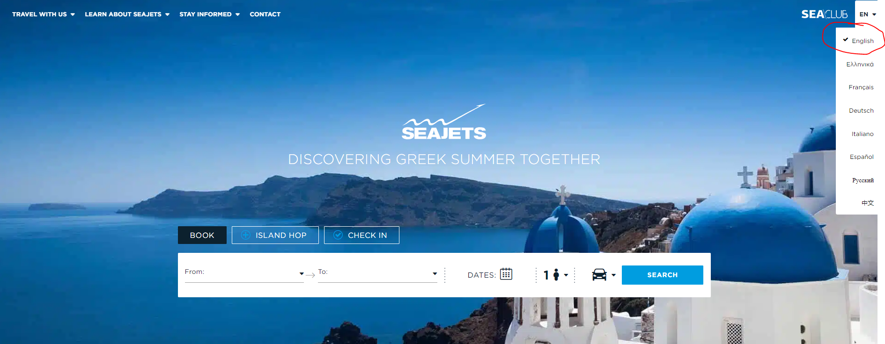
- Select from and to:
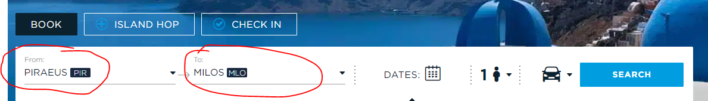
- Select “ONE WAY TRIP”:
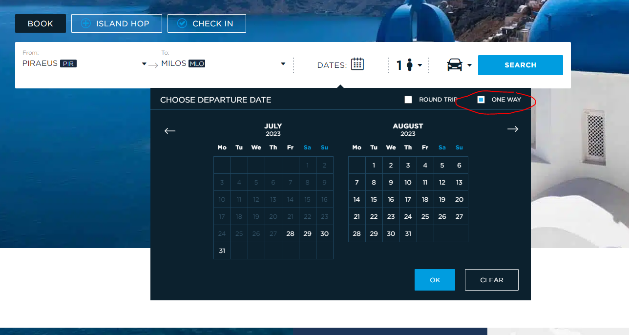
- Select the first date of our range date (15/08/2023) and click ok:
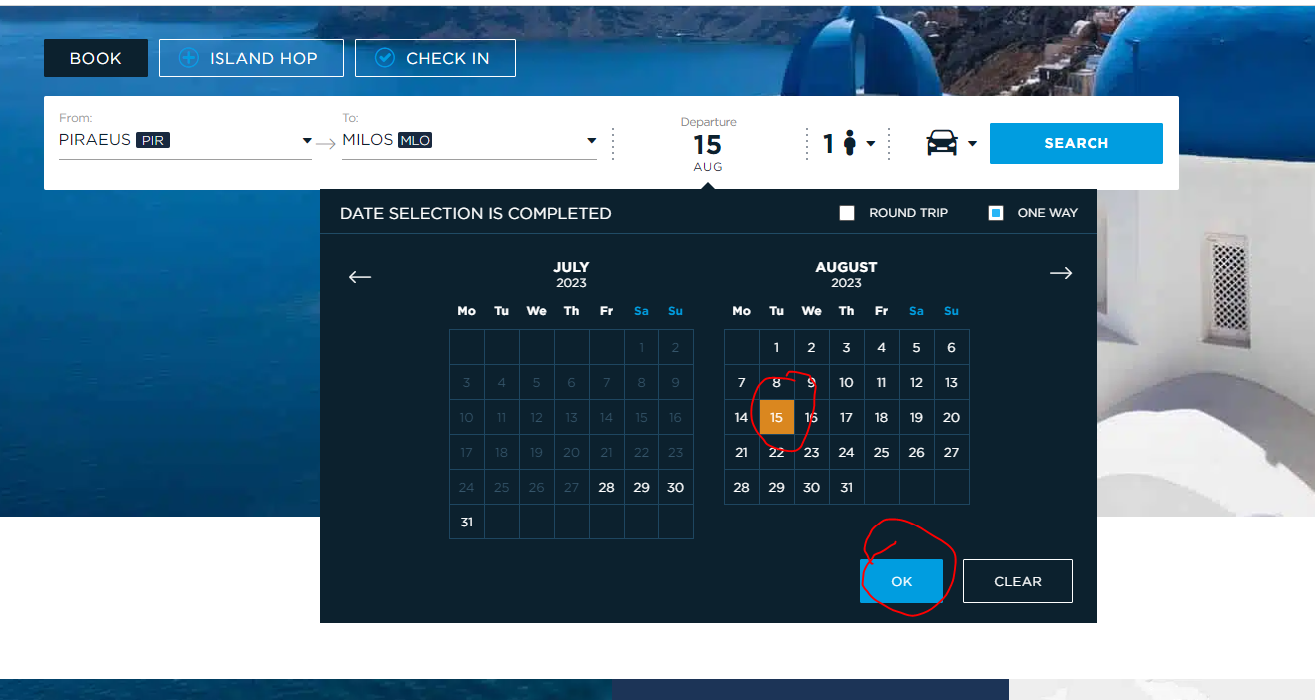
- Leave the number 1 in passengers and click ok:
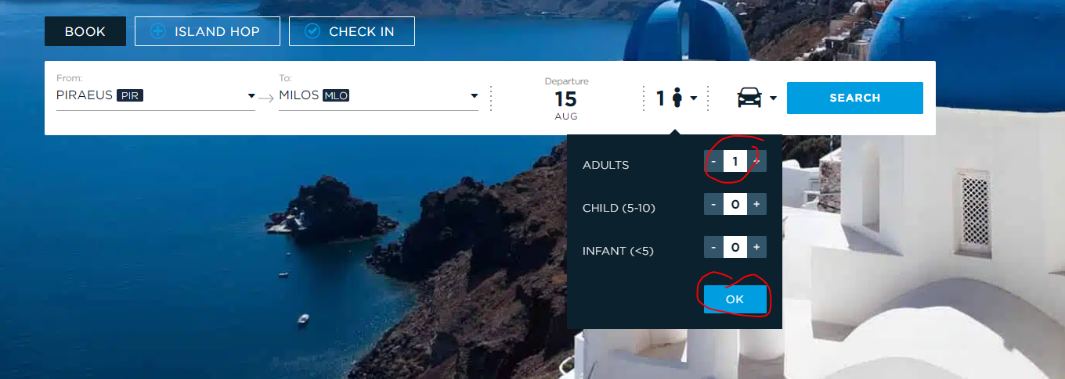
- Leave the number 0 in vehicles and click ok:
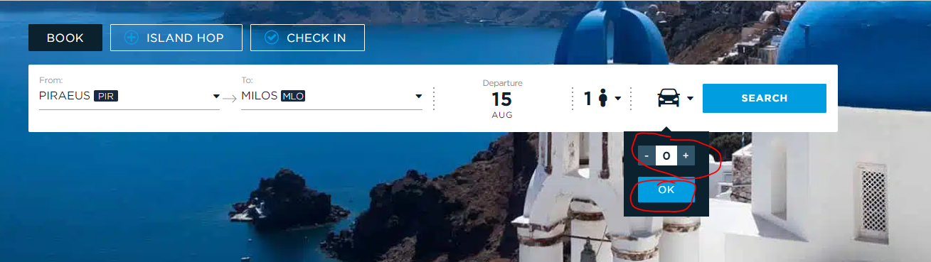
- Click Search:
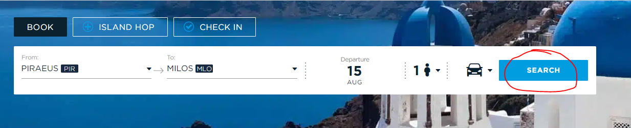
- Save the Itineraries of each date in our date range in a table (Check the format of the table at the end):
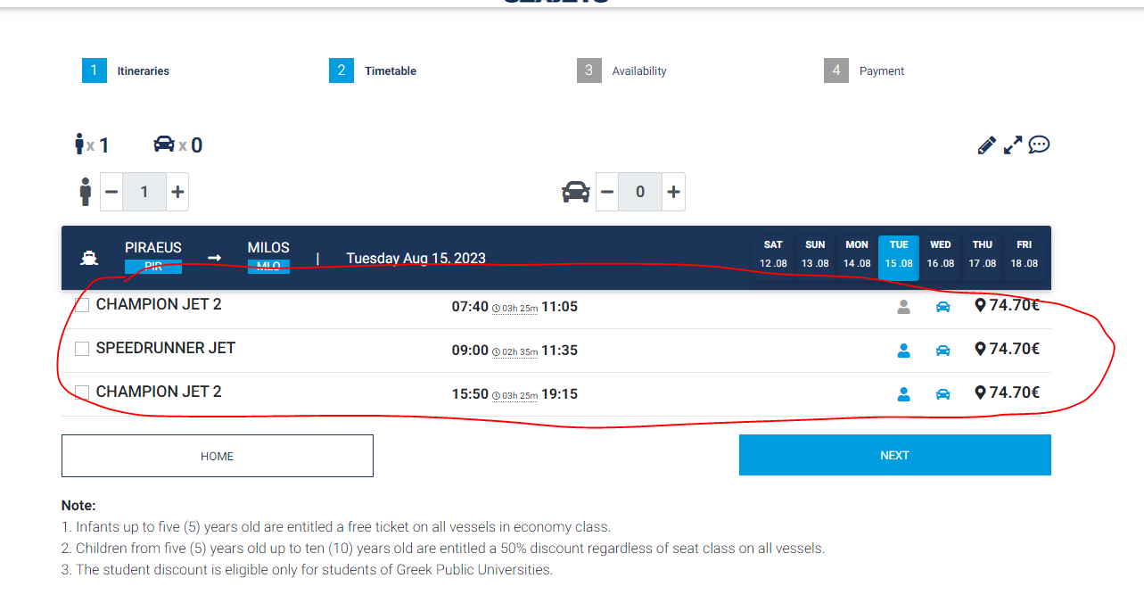
- Click on each itinerary and click next (This should be done for every itinerary):
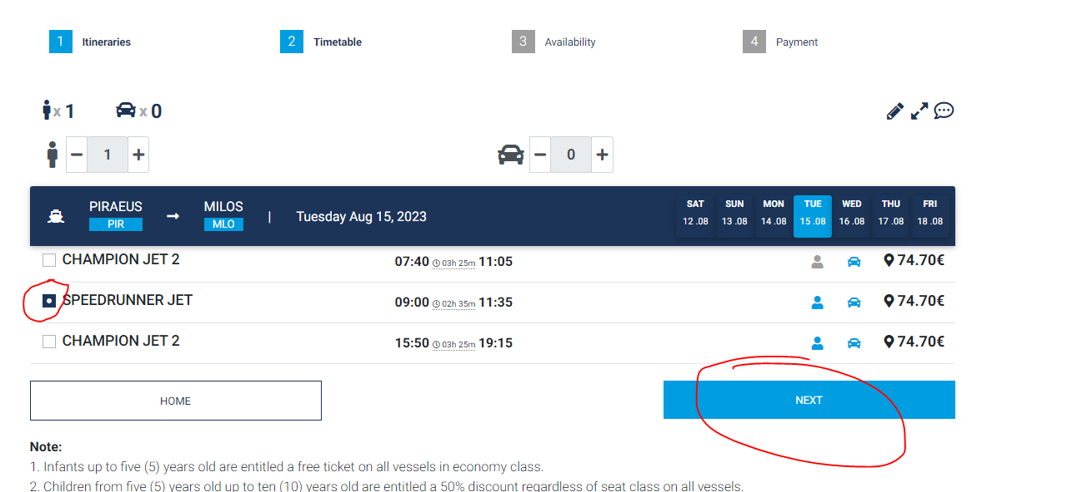
If you find an itinerary that the People Icon is grey then, move on to the next available itinerary or to the next date:
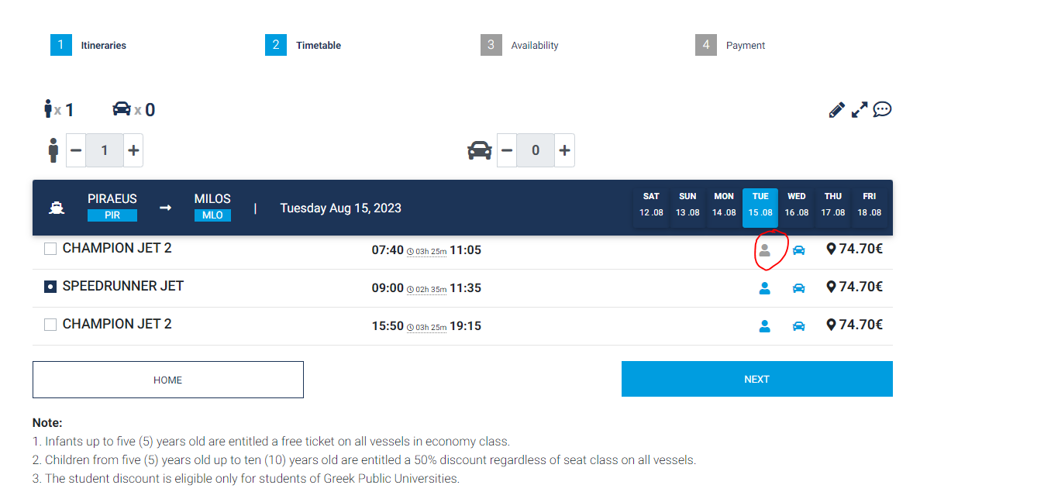
- Save the available seats of each vessel of each date in our date range in a table (Check the format of the table at the end). In our excel please save them with the name that is inside the brackets, for example INFO:
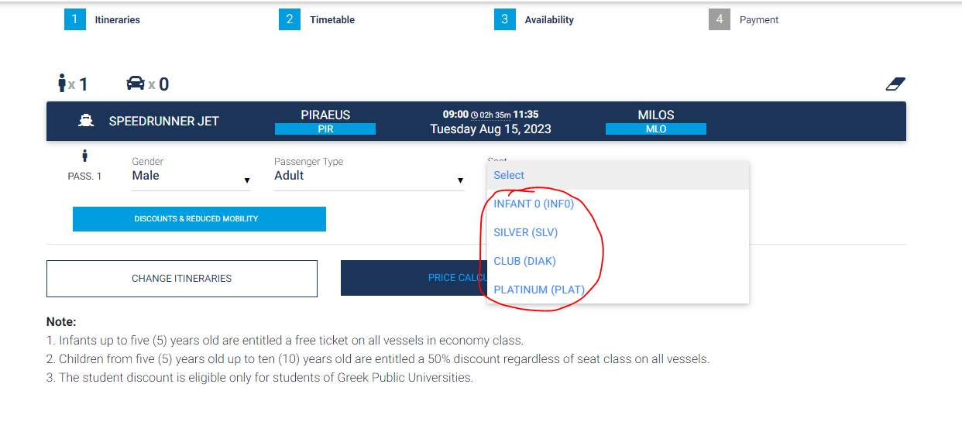
- When you finish with every itinerary of this date, then move on to the next date by clicking it:
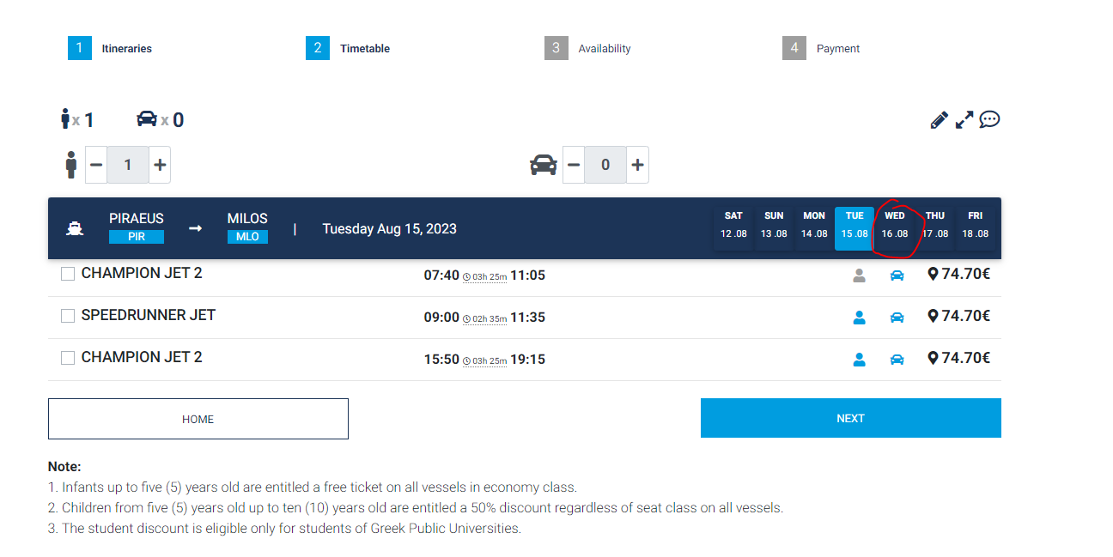

- The format of the table should be like the excel that we provided you.

